Trinity: A Stable Coin Lending Protocol Using Decentralized Credit Default Swaps

Akshit Vig¹ Kota Harsha Surya Abhishek^{2 *}Shyam Mohan J S³

¹ CEO, Autonomint Technologies Pvt. Ltd (Awaiting for Approval), India.

² Senior Blockchain Developer, Rapid Innovation, Noida, India.

³ Assistant Professor, Dept. of CSE, GITAM University, Bengaluru, Karnataka, India.
akshitvig0@gmail.com

khsabhishek1335@gmail.com

jsshyammohan@gmail.com

Abstract

Any business or enterprise transaction happens in currency, either in physical or digital mode. We are currently seeing deterioration in the transactional currencies’ value leading to reduced in capital efficiency across all asset classes. Thus, there must be a store of value that is relatively volatile but inherently stable. By using the stable coin pegged with dollars (transaction currency), we can lend it stability. This stability also comes from the psychological measure of the value of people based on our understanding of purchasing power of transactional currencies. In addition, the stablecoin will allow the holders to capture the deterioration in purchasing power of transactional currency by adding volatility to the process. This volatility comes in the form of interest rate change and protocol tokens value change, which works as a hedge against the loss in value of the transactional currency and also captures the upside of the same.

In this chapter, we propose a novel stablecoin (Trinity), a lending platform offering a Loan to Value Ratio (LVR) of 100%. Trinity combines decentralized derivative instrument Credit Default Swaps (CDS) and collateral options to manage the risks and provide adequate incentives for every stakeholder. Trinity is capital efficient and backed by strong counterparties to ensure trust in the system. We have proposed unique protocol (Trinity) to ensure safety and security for clients looking for more profits for their investments. Trinity acts as a lending protocol that enables 100 % LVR to crypto users. Apart from these features, we have tried adding features to Trinity, managing the risks related to collateral using CDS. The protocol ultimately ensures high capital efficiency of the deposited assets and brings a stable coin which caters to both retail and institutional returns and risk tolerance capacity needs.

Keywords: Crypto, Credit Default Swaps, Loan to Value Ratio.
- Introduction

Trust is the ultimate currency that drives any human interaction across the world. People trust someone or something if they have strong backing. Cash as we know it today is utilized as the medium of exchange because it has strong support from their countries’ respective governments. Two layers of trust run any business or human interaction across the world. Companies or clients pay in currencies like Rupees/Dollars to another business/person in return for the services/effort/goods delivered to each other. Here, trust in currency and trust in another business to provide the services keeps the wheels of the economy chugging along.

There was a time of the Free Banking Era when anyone could print their currency and in which there was no government interference. The free-banking laws specified that a state banking authority determined the general operating rules and minimum capital requirement without any approval. However, this issued new currency also requires the backing of government bonds. These state bonds at that time were not fully riskless but, banknotes issued against the same were at the par value of bonds. So, Banks could issue a $100 banknote by depositing a state bond with a market value of $90 but par value of $100 [1].

Highly trusted backing ensures that the system will be highly capital efficient. Banks can lend a loan against an illiquid asset like property/real estate or an intangible asset like an Ivy League college education. This introduces capital efficiency as people can take a loan against their non-cash equivalents or non-liquid assets. Similarly, corporations can issue corporate bonds against their book assets, and their credit ratings ensure that the interest charged is reasonable.

We are currently seeing a deterioration in the value of our transactional currencies [2], leading to a reduced in capital efficiency across all asset classes. Thus, there must be a store of value that is relatively volatile but inherently stable. Stability is also a function of a psychological measure of value backed by our understanding of the purchasing power of transactional currencies. In addition, the stablecoin also allows the holders to capture the deterioration in purchasing power of transactional currency, adding volatility to the process. This volatility works as a hedge against the loss in value of transactional currency [3].

The proposed model Trinity is to create a stable coin that is highly capital efficient with solid backing by the counterparties to ensure trust in the system is maintained. We have devised unique mechanisms to ensure risk is limited to parties looking for outsized or more than usual returns on their investment.
Trinity is the world’s first stablecoin and lending platform offering a Loan to Value ratio of 100%. We are also the first protocol utilizing a combination of decentralized derivative instruments like Credit Default swaps and Collateral options to manage the risks and provide adequate incentives for every stakeholder through collateral volatility. It has three core components: stable coins, Credit default swaps and options. It also has a lending protocol where the stablecoins are minted and sent to users who deposit some crypto assets as collateral. Trinity ensures that it can provide a 100% Loan to Value ratio so that clients can borrow stablecoins against the entire value of their collateral. To manage the downside risk of collateral deposited, we have devised a unique mechanism to keep the collateral value neutral to price variations that is enabled by taking a short position on the underlying collateral against the long side of trade handled by protocol on behalf of our Credit Default swaps holders. These CDS owners deposit the stablecoins in our CDS contract, and their funds are utilized to take a long position on the underlying collateral borrowers’ deposit. These CDS owners are compensated with a combination of upfront fees and ongoing periodic fees for taking the long side of the position and providing downside protection to collateral assets for borrowers. The borrowers pay these fees to CDS holders in exchange for downside protection of their collateral and a call option on the underlying collateral asset at some Out of Money strike price. The call option allows them to capture the upside of their collateral that automatically makes the CDS owners option sellers as they are also paid some fixed fees for taking the long side of the trade at some Out of Money strike price. The protocol ultimately ensures high capital efficiency of the deposited assets and brings a stable coin which caters to both retail and institutional returns and risk tolerance capacity needs.
This chapter is divided into the following sections:

Section 1: Introduction

Section 2: Background and Related Work

Section 3: Stable Coin - Challenges

Section 4: Problem Statement

Section 5: Proposed Work – The Trinity Project

Section 6: Working of the Protocol

Section 7: Risk Management and Protocol Tokens.
- Background and Related Work

Some of the most popular stablecoins in the market are USDT (Tether) and USDC (Circle), and both of them are centralized and backed by Proof of Reserves. Many crypto companies pay their employees’ salaries in USDT and USDC, which is also the preferred option among employees. As the value of the USDT is fully backed by fiat currencies, the peg always remains stable and you will always be redeemed $1 for $1 stable coin.

Other stablecoins are over-collateralized stable coins like Maker Dai, which has a native blockchain cryptocurrency like ETH or other established projects tokens as their collateral, and stablecoins are minted at the Loan to Value ratio of 60% or below mainly. These have gained the most adoption due to their over-collateralized nature, which makes the protocol less susceptible to default, and stablecoin also doesn't lose peg widely. Interest rate mechanisms are put in place to manage the demand and supply of stable coins in the market which in turn helps manage the peg of stable coin to $1[4].

Stablecoins are backed by on-chain algorithms with an algorithmic rule that manage the supply and demand of stable coins and asset backing them. They can be burned and minted algorithmically to ensure a 1:1 peg [5].

Then there are partially collateralized and partially algorithmic stablecoins like FRAX [6]. Their collateral consists of established blockchain projects like ETH and protocol tokens in a ratio that varies based on the supply and demand of stablecoins, affecting the stable coin price. If the stablecoin price is above peg, then there is a higher demand for the stable coin, which can be utilized by protocol to increase the percentage of their protocol token as backing for the stablecoin minted, leading to the adoption of their receipt widely and increase in the price of the token. This increases the projects’ market capitalization of the project and broader success and strength of protocol.

Some stablecoins just mints stablecoins in return for supplying native blockchain assets like ETH or established project tokens. These projects have these deposited assets in their balance sheet, which are volatile. Any change in the value of these assets is compensated by the minting of protocol tokens sold or bought as per the decrease or increase in asset value at a particular discount.

There have been depegging in all 4 scenarios mentioned above with major bank runs in algorithmic stablecoins and partially collateralized stablecoins. Example: The Terra Luna crash, which was based on Algorithmic stablecoin design with the protocol own asset being used as collateral to back their stablecoin [7]. The other big crash occurred with Finance stablecoin which was a partially collateralized and algorithmic stable coin [8]. Over-collateralized stablecoins have faced de-pegging during periods of high collateral volatility, affecting the auction of collateral assets at a discounted price. Even centralized stablecoins like USDC backed by Proof of Reserves had a de-pegging of more than 10% due to their budgets being affected in banks that got bankrupt due to bank runs. Sometimes, the funds are being utilized in government bonds or other assets [9], which decrease in value leading to a fall in reserves [10].

After we analyze various stablecoins, we have observed some core user tendencies towards minting and borrowing stablecoins.

1. Users want to stay long in their volatile asset but also not lose out on other yield opportunities in this fast-growing Defi space. Since there have been a lot of platforms and yield farms coming out now and then, taking leverage against your capital to take benefit of these other yields is highly enticing. Hence, people borrow stablecoins against their volatile assets to explore different works in the market.

2. Stable coin as a currency is widely accepted across all the new and established platforms. New platforms prefer stablecoins because they do not want their platform to be affected by some external risk factors or overall Defi volatility [11]. Established platforms prefer stablecoins to diversify their TVL (Total Value locked) to stable assets which will grant backing to their governance tokens or utility tokens. Stablecoin backing is similar to cash equivalent backing, which commands the highest trust among the user base [12].

3. Users want to take advantage of the peg off balance, especially when stable coin value is above peg. This way, they can borrow stable coins at 1 USD from the protocol and sell them at the market price at > 1 USD to generate a net profit.

While designing our protocol, we are aware of this reality and try to stay close to above core user tendencies as much as possible. We don’t want our protocol to mint some stable coins by exchanging some volatile crypto just because people want to go riskless and hence makes the protocol highly capital inefficient. We will then be storing the every asset (ETH or SOL) on which we are building our Defi protocol.

The proposed work provides an opportunity for users to go riskless but in the process do not lose out on their volatile crypto and always be long on the base layer assets.
- Stable Coin - Challenges

Existing collateralized lending protocols and algorithmic stablecoins have below issues:
- These protocols have a low capital efficiency — DEFI lenders will require collateral over the value of the loan so that if the value of borrowed asset drops or the value of the collateral drops, the lender still has a cushion in the form of excess collateral allowing the lender to retain their initial principal helps in saving the protocol from insolvency, but it also limits the amount of capital to be borrowed.
- Protocols need to monitor the market to set an efficient Liquidation discount constantly. Some protocols like Maker and dYdX use an auction mechanism where liquidators bid with increasing amounts of the protocol currency/borrowed asset to liquidate under collateralized accounts. These bidders will be able to get the collateral at a discount named a LD (Liquidation Discount) and then sell the collateral back in the open market at the market price, thus pocketing the profit. However, there is slippage in decentralized exchanges like Uniswap which varies with the Liquidation size. This slippage might lower or eliminate the arbitrage while selling the collateral. Thus, these protocols need to constantly monitor the market and re-evaluate their Liquidation discount (LD) to both ensure overpaying of collateral when the market rate is lower as well as ensure not underpaying when the market rate is higher, which will lead to no one bidding for liquidation leading to insolvency risks.
- Algorithmic stablecoins backed by another stable coin - These stablecoins backed by a stablecoin asset which doesn’t fulfill the need of users to stay long in their current crypto asset and capture the yields through price appreciation in them.
The proposed work tries to solve these issues.
- Problem Statement

The above challenges have motivated us to work on the Trinity. Some of the problems faced in real-time:
- There is a need to create a stable coin that is highly capital efficient with solid backing by the counterparties to ensure trust in the system is maintained.
- Current stablecoin protocols need to design better incentive and user-friendly mechanisms for their borrowers. Borrowers have to monitor their collateralization ratios to avoid the risk of getting liquidated. This limits the borrowing capacity to a lower Loan to value ratio so that the borrowers’ have some leeway to manage liquidation risk that decreases the capital efficiency of the protocol. Although there are projects out there that through some subscription fees provide services of maintaining the collateral ratios it introduces another overhead on top of the borrowing fees.
- The current stablecoin does not provide downside protection for borrower collateral. So, during bearish times, there is a higher risk of collateral liquidation leading to less utilization of these projects and less minting of stable coins which can have a ripple effect on the strength or crypto economics of these projects.
- Current stablecoin projects still need to build a capital efficient way to manage liquidations with incentive structures not attractive enough for liquidators. The best way now is to create a readily available pool of stablecoins utilized to manage liquidations at a particular discount.
- Proposed Work - The Trinity Project

Trinity is a stablecoin that many competitors ranging from dollars and other currencies across the world. With hyperinflation coming, there must be a store of value that is relatively volatile but inherently stable. Through the proposed model, we aim to provide the best capital efficiency to every participant involved. The project has three components, as mentioned below:
- Stablecoins - are issued upon locking collateral like ETH. The LTV (Loan to Value) ratio will be 100%.
- Decentralized CDS (Credit Default swaps) - The second part of the Trinity are Credit Default Swaps. Depositors can enter CDS with the protocol and get regular funding payments apart from the interest rates they earn by depositing their stablecoins on protocol. Participants can earn more than 100% APY over and above the meager interest rates they receive from depositing their assets. The CDS owners will also act as can also be avail of the service of option premiums by which their assets will be readily available in case of default by the borrower compensated with option premiums in return for the same.
- Collateral options - The collateral options are the source of fees for CDS owners. The idea behind collateral options is to give an option to the borrower for creating lossless strategies. In traditional finance, people buy options to hedge their downside and create a limited loss strategy. Using the same method, upside is maintained as the collateral options are a form of call options that allows the borrower to earn all the upside above a particular strike price. As the borrower enters into the contract with the protocol and takes a loan against Ethereum or any other collateral, another contract will get active. Upon paying an upfront option price, the borrower can hedge the downside risk.

These three will work together to maintain the peg of stablecoin and manage collaterals and defaults. The protocol will have two types of user-base with different risk tendencies and opinions about the market.
- The first type of users will be borrowers who want to mint stablecoins and long the volatile crypto asset that they hold. These users also want to maximize their deposited capital’s efficiency. To achieve the same, the users can mint and borrow the stablecoins against their deposited capital at the maximum LTV ratio of 100%.
- The second type of users will be something called Credit Default swap owners. Credit Default Swap (CDS) allows one to swap the credit/default risk in exchange for some periodic fixed fees. In its aim to provide a 100% LTV ratio to borrowers, the protocol faces the credit/default risk when there is a decrease in deposited capital (collateral) value. This protocol will protect itself against these credit risks with the help of CDS owners. The protocol will swap the credit risk from itself to the CDS owners. These users will deposit the stable coins in CDS contracts. The stablecoins deposited will act as a counterpart and their capital will be utilized to counter the credit risk generated on decreasing collateral value. These CDS owners' capital will be locked, and in return, they will be compensated with a combination of upfront fees and periodic fees, which will help them achieve returns near to 100% APY.
  - Option Fees exchanged among the participants

The collateral option fees are shared from borrowers to CDS owners achieved through an options derivative. The protocol will also have a ‘delta neutral contract’ where borrowers' capital and CDS capital will take short and long position respectively. This will help achieve downside protection on borrower’s capital and help the protocol to capture an upside of the borrower’s capital and utilize that upside to provide excessive returns to CDS owners and borrowers. For the initial few years, the Protocol parameters will be handled by our core team to ensure stablecoin peg is maintained with appropriate incentives created. We will automate most of the parameters over the course of this stabilization period in order to achieve an equilibrium state where the protocol runs smoothly.
- Working of the Protocol

Figure 1 shows the functional model of the proposed work.
  - Stakeholders in Protocol

1. Borrowers – Borrows stable coin by depositing acceptable volatile assets (Ethereum) as Collateral

2. Credit Default Swap owners – Deposits stable coin, utilized by the system to provide downside protection for the ETH deposited by borrowers
  - Tokens in Protocol

1. Stablecoin

2. Option

3. Protocol Token (generated when CDS owner loses money)

The borrower borrows a stable coin against collateral deposited. Let’s assume the collateral deposited is Ethereum into the Ethereum Vault. On the other hand, the CDS owner deposits a stablecoin utilized in case of borrower’s defaults. Protocol now in order to give downside protection of collateral to borrowers will engage in a short position using ETH in the ‘ETH vault’ on the underlying asset i.e., ETH price. Conversely, Protocol will take CDS stable coin deposits and put them in a long position on the ETH/USD price. Now, if the ETH value decreases, the short work will profit by an equivalent increase in value captured by deduction of the same amount from the long position. Also, if the ETH value increases, the long work will profit by an equivalent increase in value after deducting the same amount from the short position. However, the rise in ETH price in ETH vault creates a net neutral strategy for short position holders thus offering them downside protection. Thus, we achieve our objective of creating a delta-neutral plan by providing downside protection to borrowers and protocol during the decrease in collateral (ETH) price. Now, the borrowers don’t have to worry about confiscating of their collateral due to breach in LTV (Loan to Value) ratios. They can now generate yield during bearish times as their collateral value is not decreasing.
However, by creating this delta- neutral strategy, we have also made a limitation in capturing the upside of collateral i.e., increase in the price of the ETH, which is very dear to borrowers and one of the big reasons for them not letting go of their collateral. So, we solve this issue with the help of a collateral option’s mechanism illustrated in the later sections.

The deposits of stablecoin are locked for some duration. Also, the CDS owners will be getting option fees from borrowers in return for offering their stablecoin deposits to offer downside protection from borrowers. Minting of protocol tokens is done when the collateral value is 90% of the borrowed amount and when the collateral value has touched 80% of the borrowed amount. In the initial stages of the protocol, we will be offering downside protection based on the volatility of Ethereum. We plan to 20% downside protection for collateral.

There is an alternate mechanism of providing protection of CDS deposits by generating a bond or hedge token which will be given to CDS once they unlock their deposit after fulfillment of contract unlock conditions. This bond or hedge token will have a maturity of 6-12 months. These bonds/ hedge token's value will depend on the total amount pending for maturity at different time durations. This bond/ hedge token can be with other participants.
  - Components of the Protocol

Borrowing of stablecoins

A borrower deposits ETH as collateral, and the protocol mints the equivalent value of stable coin in 100% Loan to Value ratio.
- Track the price of ETH at the time of borrowing to store the USD worth of collateral deposited by the borrower. Every borrower will have its dollar worth collateral amount stored in the smart contract parameters when borrowing.
- Protocol immediately deposits ETH into the ETH vault and takes a short position on the Delta neutral contract.
- Protocol mints stable coin equivalent to USD worth of ETH collateral deposited

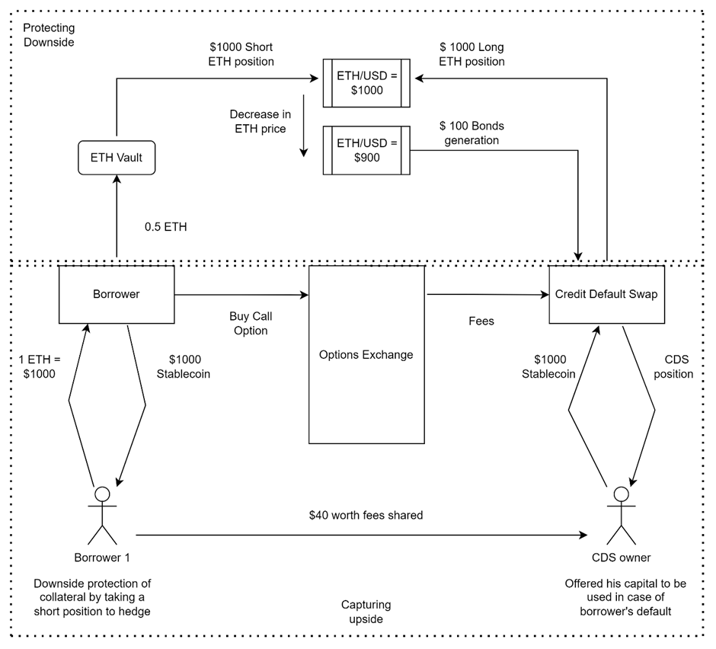

Fig.1.Functional Mechanism of Project Trinity
- Total Debt for a particular Vault = Amount borrowed + Borrowing Fees

At t =0, APR = 12% (where APR is the Annual Percentage rate of borrowing written in decimals)

Assumptions
ETH Price = $1000

Collateral Deposited = 1 ETH = $1000

Stablecoin Borrowed, B = $1000

Total Debt at time t = B*(1+APR/n) ^{nt}

Where n is the number of compounding periods per unit of time

Where t is the time in decimal years

While calculating the Total Debt of Protocol, we don’t need to loop across all the individual vaults to calculate the Total Debt by looking at the particular time for every vault since borrowing. Instead, whenever a new borrower comes the amount, we will keep adding and deducting the total borrowed amount. After addition or deduction, we will multiply the amount with the current rate and time since the last borrower came or the last event that happened in the borrowing contract.

Therefore, Total Debt to be returned by borrowers = Total Vaults Debt * (1+APR/n) ^{nt}

So, there is no need to loop across all the vaults every time, which can make our contract very complex and time-consuming.

Below mentioned are the two scenarios where ETH price increases and decreases to highlight the effect on the capital of borrowers, CDS owners, and protocol deposits

Borrowers - B1, B2, B3, B4, B5

Borrower's collateral value at different ETH prices - D1, D2, D3, D4, D5.

ETH price incrementing by 100USD every periodic interval

Table 1. Change in Borrower’s positions
ETH Price |  | 1000 | 1100 | 1200 | 1300 | 1400
ETH Price | Short Position
ETH Price | Borrower | D1 | D2 | D3 | D4 | D5
ETH Price | B1 | 1000 | 900 | 800 | 700 | 600
ETH Price | B2 |  | 1100 | 1000 | 900 | 700
ETH Price | B3 |  |  | 1200 | 1100 | 1000
ETH Price | B4 |  |  |  | 1300 | 1200
ETH Price | B5 |  |  |  |  | 1400

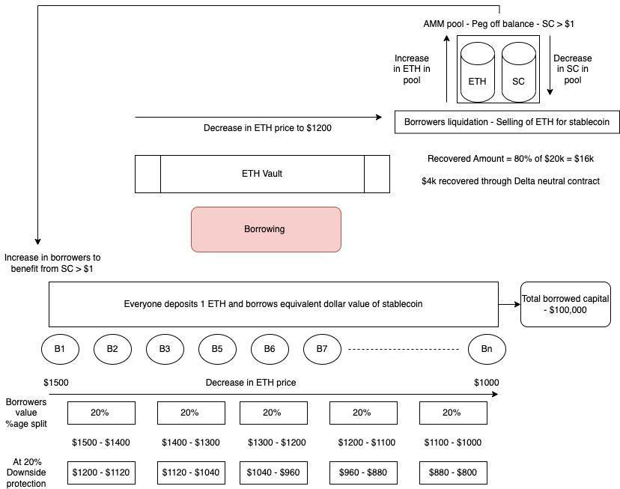

Fig.2.Borrowing Module

1. Change in CDS (Credit Default Swap) holders’ positions
Table 2. CDS Pool contains 2 CDS holders’ deposits - CDS 1 & CDS 2

Long Position
Pooled CDS positions | D1 | D2 | D3 | D4 | D5
CDS pool value | 2000 | 2100 | 2300 | 2400 | 2500
Bonds minted |  | 0 | 0 | 0 | 0

2. ETH price decreasing by 100USD decrement

Table 3. Change in borrower’s positions
ETH Price |  | 1000 | 900 | 800 | 700 | 600
ETH Price | Short Position
ETH Price | Borrower | D1 | D2 | D3 | D4 | D5
ETH Price | B1 | 1000 | 1100 | 1200 | 1300 | 1400
ETH Price | B2 |  | 900 | 1000 | 1100 | 1200
ETH Price | B3 |  |  | 800 | 900 | 1000
ETH Price | B4 |  |  |  | 700 | 800
ETH Price | B5 |  |  |  |  | 600

3. Change in CDS (Credit Default Swap) positions
Table 4. CDS Pool contains 2 CDS holders’ deposits - CDS 1 & CDS 2

Long Position
Pooled CDS positions | D1 | D2 | D3 | D4 | D5
CDS pool value | 2000 | 1900 | 1700 | 1400 | 1000
Bonds minted | 0 | 100 | 200 | 300 | 400
Total Bonds minted |  | 100 | 300 | 600 | 1000

Bonds or tokens minted when the CDS owner tries to unlock their position that can be unlocked after a certain time threshold and certain protocol parameters conditions like the ratio of the total number of borrowers to the total number of CDS owners.

Credit Default Swap Entry by Holders
- Each CDS holder will deposit the Trinity stable coins after buying from a market in the CDS contract in multiples of $500
- The contract will save each CDS holder position.
- The pooling of the total amount and taking a long position on a Delta neutral contract will be done.
- An option seller utilizes the pooled amount in an options contract on behalf of CDS holders. This way, the CDS holders will get the option fees from borrowers.
- The decision to unlock CDS holder stablecoins is based on tracking a combination of fixed term and protocol parameters.

The ratio of CDS holders/ Ratio of borrowers >= 0.2

The above ratio should be greater than 2 to unlock the CDS positions.

Delta-Neutral Contract (Downside Protection for Borrowers)

A Delta neutral contract involves taking two opposite positions on the price of ETH/USD.
- One is the short position taken by the borrowers ‘on ETH/USD, and the other is the long position taken by the CDS holder on ETH/USD
- Assuming a 10% decrease in the price of ETH, the CDS holder's short position will cause a corresponding 10% increase in USD value to be added for each ETH held in the ETH vault. This additional amount will be subtracted from the CDS long position.
- These are synthetic positions, and no cash settlement is happening on every change in price after every periodic interval.
- Cash settlement only happens if a CDS holder wants to withdraw his amount after a lock-in of 1-month duration is over. At that moment, we will calculate the final balance of the total pooled amount. If the amount is positive than the amount pooled, then a fraction of the amount will be deducted and given to the CDS holder.

Calculation of balances of a long position and short position

1. Short position (Borrowers)

a. Calculate the quantity of ETH deposited in the ETH vault

b. Track the price of ETH in periodic intervals (1 min)

c. If the Price of the ETH in the current periodic interval is higher/lower than the previous periodic interval, then the total balance of the short position will be deducted by the below formula:

X = (Total number of ETH in ETH Vault * ETH Price change (Between Periodic intervals)

Short Position Balance = Total Short Position Balance – (Total number of ETH in ETH Vault * ETH Price change (Between Periodic intervals)).

2. Long Position (CDS Holder)

a. Calculate the total amount of stablecoin deposited in pool

b. As the price of collateral (ETH) changes, there is a change in the CDS pool long position balance

Total Long Position Balance = Long position balance in previous interval + X (Real)

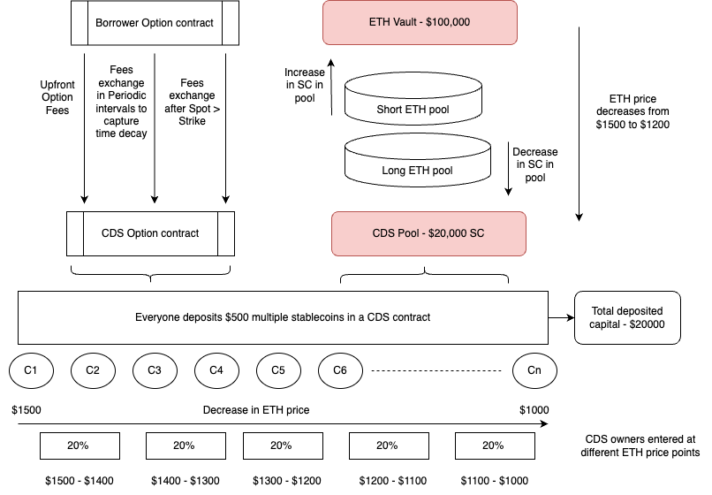

Fig.3. CDS module

Option’s contract

Earlier versions based on the ERC20 standard failed to adequately distinguish between principal and interest payments while also accommodating for differing rolling maturities. In the past, holders encountered theta decay as all positions neared maturity simultaneously, leading to a prisoner's dilemma [13]. The duration is measured in seconds utilizing Unix-timestamps, as permitted by Solidity.
- The design of the option contract aims to offer borrowers a means of benefiting from a potential increase in the price of ETH. This is accomplished through the purchase of a call option at a specified strike price.
- Furthermore, the option contract facilitates the transfer of option fees from option buyers (i.e., borrowers) to option sellers (i.e., CDS holders), thereby allowing CDS holders to earn a high yield APY on their deposited funds while maintaining a Delta-neutral position for borrowers.
- There are 5 variations of strike prices that borrowers can take – 5%, 10%, 15%, 20%, and 25%. It implies that borrowers can buy a call option on ETH price on the above percentage ranges for strike prices only
- The option price will decrease from a 5% strike price option to a 25% strike price option as per the risks

There are three different approaches to designing an option fees exchange mechanism:

First Approach
- There will be only five markets for option prices -
  - Borrowers who have purchased a call option at a strike price of 5% will be grouped together.
  - Borrowers who have purchased a call option at a strike price of 10% will be grouped together.
  - Borrowers who have purchased a call option at a strike price of 15% will be grouped together.
  - Borrowers who have purchased a call option at a strike price of 20% will be grouped together.
  - Borrowers who have purchased a call option at a strike price of 25% will be grouped together.
- At the start, the option market will only offer a 5% strike price option. Thus, all borrowers will participate in the options contract by purchasing a call option at the 5% strike price.
- Option Price calculation

For a borrower buying a 5% strike price option when the ETH price is at $1000 so the strike price is $1050

He pays some Initial Option Fees = 20$

Option Price = Current Option Price * (1+ % change in ETH price from the contract start * 10) - (Time decay affect on Price)

Option Price also changes if some borrower comes in between to sell its option at the current price. So, that seller will be given the increase in option price by deducting the same amount over the left borrowers who are still holding the option implying they are bullish on the option price and thus acting as a counterparty to the borrower looking to exit from his option contract.

Second Approach
- Once an option buyer enters into an options contract, they will receive an NFT representing their position at the 5% strike price. They may then choose to list the NFT in a marketplace for sale at a specific price.
- Potential buyers of the NFT may purchase it at the listed price and subsequently deposit it into our protocol, enabling them to receive any benefits resulting from the ETH price being above the strike price on the specified expiry date.

Third Approach

The option prices with no maturity dates and five strike price options
- Borrowers who have purchased a call option at a 5% strike price will be grouped together.
- Borrowers who have purchased a call option at a 10% strike price will be grouped together.
- Borrowers who have purchased a call option at a 15% strike price will be grouped together.
- Borrowers who have purchased a call option at a 20% strike price will be grouped together.
- Borrowers who have purchased a call option at a 25% strike price will be grouped together.

Total Option fees = 40% Upfront Payment + Continuous stream of option payments for time decay in option price with no maturity dates

For Instance, ETH spot price = $1000

The borrower deposits 1 ETH as collateral to borrow a $1000 stablecoin.

Borrower takes a call option at a 5% strike price with no expiry of the maturity date. So, the strike price is $1050.

Total fees = Upfront Option Fees + Continuous stream of option payments to capture theta decay + Option Fees to maintain position ( If Spot > Strike)

Total Fees = $10 + $20 (Continuous fees deduction from $20 in 1% percentage points corresponding to theta decay) + (%age Deduction of overall upside as long as the position is kept open)
- Risk Management and Protocol Tokens

Our protocol is designed to provide borrowers with downside protection on their collateral while also enabling them to capture the potential upside. This is currently achieved through a combination of CDS capital [14] and collateral options used as incentives.

It is crucial for our protocol to have the necessary flexibility to manage risk and incentivize participants appropriately. This will be achieved through the use of Protocol tokens, which will only be minted and burned based on the actions of participants. We recognize the importance of time value of money in providing yields to parties, whose assets are utilized by a counterparty to manage project operations, drawing upon traditional finance principles. In our protocol, we also utilize the assets of CDS owners to manage downside risk of collateral. As compensation, they receive upfront fees and a continuous flow of fees for time decay in options. The Protocol Tokens will serve as a risk management tool for both the protocol and CDS owners.
  - Approach 1

The protocol is designed to manage risk by providing appropriate incentives for participants in the form of Protocol tokens. These tokens will be minted and burned only based on participant's actions, and they will be utilized as a risk management tool for both the protocol and CDS owners. The protocol has a downside protection built in through its Delta-neutral function, but it also needs flexibility to manage risk by reducing its reliance on collateral assets' volatility.

It provides incentives through protocol tokens to diversify the risk from collateral assets to protocol tokens. The protocol tokens' mint function will get activated when the borrower's collateral has fallen down to 10%, and the number of protocol tokens minted will be twice the fall in collateral value. These tokens will be provided to the borrower on returning the stablecoins borrowed. The provided tokens are double the value of loss in collateral, so they act as an incentive for the borrower to earn an upfront yield. This higher yield compensates for the higher yields that the borrower could have earned by locking or staking their stable coins on some protocol.

By diversifying the risks from collateral volatility to protocol tokens, the protocol has higher flexibility in managing risks. The protocol will mint tokens that will be distributed after some term or time duration to the CDS owners. This will act as yield on locking of the CDS capital for higher durations with the protocol.

It can be observed in current decentralized lending platforms such as Compound Finance that stablecoins provide significantly higher supply APYs (20-40 times) compared to volatile assets like ETH. This yield is even more substantial for tokens with active yield farming programs. [15]

By depositing Ethereum to borrow stablecoins, individuals can potentially earn higher yields by efficiently utilizing their stablecoins. Despite the deduction of borrowing fees, the yields offered on stablecoins are higher due to their non-volatile nature.

Our protocol includes a Delta-neutral function to provide downside protection. However, we also recognize the need for flexibility in managing risk by reducing our reliance on collateral asset volatility. To achieve this, we plan to incentivize participants with protocol tokens, which will diversify the risk from collateral assets to the tokens themselves. When a borrower's collateral falls to 10%, our protocol tokens mint function will activate, creating tokens equal to twice the collateral's fall in value (e.g., 20% of collateral value if it has fallen to 10%). Upon returning the borrowed stable coins, the borrower will receive these tokens as an upfront yield. The double value of the tokens relative to the loss in collateral serves as an incentive for the borrower to earn a return. The upfront tokens compensate for the higher yields the borrower would have earned by locking or staking their stable coins on other protocols.

The CDS owners take on a significant amount of risk in exchange for large option fees. However, their participation is solely based on their view of the collateral assets' volatility. If the collateral asset's volatility is low, then they will benefit from higher returns through option fees. Conversely, if the volatility is high, their returns are more likely to be negatively impacted. By diversifying the risk from collateral volatility to protocol tokens, we gain greater flexibility in managing risks within the protocol. The protocol will mint tokens that will be distributed to CDS owners after specific time duration, providing a yield for locking CDS capital for longer periods with the protocol.

One potential issue with the protocol's 100% LTV is that users may attempt to game the system by borrowing stable coins to buy ETH, and then using that ETH as collateral to take out another loan. However, since fees are deducted from the original stable coin loan, the actual loan value is closer to 95%. This means that repeatedly opening borrowing positions in this way would not significantly impact the system, as the borrowed value is eventually returned. The only systemic risk would be if the collateral for all of these borrowing positions were to fall in value, which could impact the CDS pool.
  - Managing Liquidation in Protocol

Method 1

We have a set of borrowers Br = {b1, b2, b3, b4…………..bn)

Where bi denotes the i-th borrowing position

It is a single collateral lending protocol with stable coin borrowed in an LTV ratio of 100%

Assuming the collateral utilized is the ETH, we have all these borrowers coming at different points of time at different ETH prices and borrowing stablecoin loans at 100% LTV.

Thus, the ETH prices associated with this group of borrowers can be represented as:

Er = ( E1, E2, E3,E4…………….En)

Where Ei represents the ETH price for the i-th borrowing position

The collateral amount will be a fraction or multiple of ETH value, with Ci denoting the collateral deposited by the i-th borrower.

The debt taken in stablecoin is equivalent to the price of the ETH at an LTV of 100% LTV

As the borrower also needs to engage in an option contract along with the borrowing, the borrower needs to pay some option fees to provide downside protection to collateral and capture ETH upside if the price rises above a particular strike price. We will deduct these fees at the time the borrowing occurs from the Loan value taken by the borrower.

These option fees are a combination of upfront and fees for taking a perpetual position in the call option. After deducting the perpetual call option fees corresponding to the time decay of a particular borrowing position, some of them will be returned. If a borrowing position is closed early, the borrower will receive the fees back.

The prices will be calculated on the below factors:
- The fees will have a $10 minimum cap
- The fees will be dependent on the strike price of the perpetual call option. Payments will be higher for a higher strike price option.
- The upfront fees will be determined based on the percentage of downside protection provided to the collateral amount. Initially, the protocol will offer 20% downside protection.

Upfront fees = 10% * 20%* Ci*Ei

Perpetual Option Fees will be calculated based on the strike price.
- We will group together borrowers who purchased a call option at a 5% strike price.

40%* (Strike Price of ETH - Ei)
- We will group together borrowers who purchased a call option at a 10% strike price.

30%* (Strike Price of ETH - Ei)
- We will group together borrowers who purchased a call option at a 15% strike price.

20%* (Strike Price of ETH - Ei)
- We will group together borrowers who purchased a call option at a 20% strike price.

10%* (Strike Price of ETH - Ei)
- We will group together borrowers who purchased a call option at a 25% strike price.

5%* (Strike Price of ETH - Ei)

The perpetual option fees will have a time decay deduction of fees every day from the perpetual option fees.

Time decay = 0.1$ + 10% * (ETH price change every day)
  - Liquidation management

We manage liquidation by minting protocol tokens. However, we can still wait for liquidation to happen and then take action. We will proactively action to protect the protocol against any liquidation or strive to earn some yield until the liquidation happens (in two ways):
- Earning yield from collateral deposited - We will split the collateral value into two parts half of the collateral will be deposited in some other protocol to earn yield, and half of the collateral will be kept here to offer downside protection in our See-Saw function.
- Minting of protocol tokens at various stages will be done when the collateral value is 90% of the borrowed amount and when the collateral value has touched 80% of the borrowed amount. When the collateral value touches 80% of the borrowed amount, we give them protocol tokens in return for stablecoins. We will apply some Liquidation discount before giving protocol tokens. This mechanism will ensure that we do not have to take our collateral back from an external protocol which might charge us some fees and lose out on yield on the collateral deposited.

If Di is the debt in stablecoin taken by the borrower bi, then at 100% LTV

Di = Ci * Ei

Rt denotes the value of collateral ETH at time t

So, the health of the borrowing position,

Hi = ( Ci * Rt ) / Di = (Ci *Rt) / ( Ci * Ei) = Rt / Ei

The health of the borrowing position will mainly vary from 0 to 2 approx. Considering that with the rise in the value of Hi, the borrower has increased incentive to close his position and take the increase in value. We will mint protocol tokens at different stages.
- When Hi approaches 0.9, the protocol tokens will be minted based on the below formula:

If the market price of protocol tokens = Pm

Protocol Tokens = [( Ei - Rt) * 2] / Pm
- When Hi approaches 0.8, we will mint the protocol tokens again. We will use a Hypothetical Liquidation discount (U) to determine the value of the protocol tokens minted for Liquidators.

Protocol Tokens = [0.1 * ( Ei - Rt) ] / Pm

Here, Hi of 0.9 & 0.8 are dependent on the ETH volatility and CDS volumes/Borrower volumes

Example

Assuming the current market price of ETH, Rt = $1000

The borrower, bi, puts 1 ETH as collateral. In return, the protocol mints $1000 Trinity SC

So, here Ci is the collateral as a multiple of ETH = 1

Also, Ci*Ei = 1*1000 = $1000

The borrower also chooses the 5% strike price i.e., $1050

So, the option price for borrower = Upfront Option fees + Perpetual option fees

= 0.1*0.2*Ci*Ei + 0.3*(Strike Price - Ei)

= 0.1*0.2*1000 + 0.4*(1050-1000)

= 20 + 20 = $40

So, out of 1000 Trinity SC minted, we will take 40 SC as Option Fees leaving the borrower with 960 SC

We have different scenarios as follows:
- ETH fell to $950

The health of borrowing position, Hi = 0.95

If borrower decides to come and return $1000 SC, then he will get his ETH and $50 SC.

Essentially, the borrower will only receive $950 SC and get their ETH back.
- ETH fell to $900

So, here Hi = 0.90

Let’s, Protocol tokens, Pm = $2

The protocol will mint Protocol tokens = [( Ei - Rt) * 2] / Pm

= [(1000 - 900) * 2]/ 2

= 100 Protocol tokens

In this case, if the borrower decides to return $1000 SC, they will receive their ETH back after 3 months, but they will immediately receive 100 Protocol tokens. Essentially, the borrower will only need to return $900 SC to receive the 100 Protocol tokens.
- ETH fell to $850
Here Hi = 0.85

In this case, if the borrower decides to return $1000 SC, they will receive their ETH back after a 3 month time period, but they will receive the previously minted 100 Protocol tokens. Essentially, the borrower will only need to return $850 SC to receive the 100 Protocol tokens.
- ETH fell to $800

Here, Hi = 0.8

In this case, the borrower's collateral assets will become protocol assets, meaning Protocol will become the owner of the ETH. The Liquidator will receive the earlier 100 Protocol tokens plus an additional 10% of Protocol tokens, and in exchange, will give 200 SC to Protocol for the Protocol tokens.

So, the liquidator will get = [0.1 * ( Ei - Rt) ] / Pm

= 100 + 0.1* (1000 - 800)/2

= 100 + 10 = 110 Protocol tokens

Liquidator will get = 1.1 * [( Ei - Rt) / Pm] it will be a direct call from the user (depositor of that particular index cannot be a Liquidator/user).
  - Calculation of CDS depositor returned amount on withdrawal

We should know the total amount to be returned to the CDS depositor after a particular time period. The exchange of funds between the ETH pool and the CDS pool will be calculated after every CDS action or borrower action. As soon as a CDS deposits funds into our platform, we will identify them.
- Current ETH market price, Er
- Amount of CDS funds deposited/Total CDS deposited funds till now (Cd/C)
- Total number of ETH holdings in our ETH pool

We will then calculate the current value of CDS funds in our protocol

Total CDS Deposited Funds = C

CDS deposited funds = Cd

CDS current funds = Cr1

So,

Cr = Cd + (Cd/C)*(Er - Ei)*(Total Eth Holdings)

We will calculate the division of exchanged funds among the total CDS depositors using the above formula. As soon as there is a new depositor or borrower or any sort of new event, the value of different figures in the formula will change. After the new event, the division percentage of exchanged funds will be changed accordingly.

Thus,

Cr2 = Cd + (Cd/C)*(E_{r}- E_{i+1}) * (Total ETH Holdings)

So, after every event, the reward percentage split changes, which require us to calculate the rewards split between two deposit intervals among all the CDS depositors until that moment. This exercise will be too computationally intensive for the smart contract considering there might be 100s of thousands of CDS depositors. Also, calculating the reward split before every new CDS deposit would delay the transaction completion time and considerably affect the user experience.

In order to manage the above situation, we will maintain a record of reward split for only one standardized deposit amount. For a start, we have considered that deposit amount to be $1000. So, before every new CDS deposit transaction, we will calculate the proportionate reward for $1000 worth of deposits and update the total amount after every transaction. By recalculating the division percentage of exchanged funds, we will be able to determine the final amount to be returned to the CDS when they try to close their position. The total amount for a particular CDS will be a fraction or multiple of the current total amount of the standard $1000 deposit figure. This allows us to identify the value accrued to a CDS position during the time of withdrawal, which is one of the critical values to calculate in the operation of our See-Saw contract.

Table 4. CDS Depositors Calculation
Day | Total ETH | Initial ETH capital | ETH price | Initial CDS amount | CDS Pool | CDS depositors | Total | Net value of CDS Pool
1 | 51 | 50000 | 1000 | 10000 |  | 1000 | 11000 | 11000
2 | 52 |  | 1010 |  | 510 | 1000 | 12000 | 12510
3 | 53 |  | 1020 |  | 1030 | 1000 | 13000 | 14030
4 | 54 |  | 1030 |  | 1560 | 1000 | 14000 | 15560
5 | 55 |  | 1040 |  | 2100 | 1000 | 15000 | 17100
6 | 56 |  | 1030 |  | 1550 | 1000 | 16000 | 17550
7 | 57 |  | 1020 |  | 990 | 1000 | 17000 | 17990
8 | 58 |  | 1010 |  | 420 | 1000 | 18000 | 18420
9 | 59 |  | 1000 |  | -160 | 1000 | 19000 | 18840
10 | 60 |  | 950 |  | -3110 | 1000 | 20000 | 16890

Table 5. CDS Depositors Values obtained - Day wise
 | Day 2 | Day 3 | Day 4 | Day 5 | Day 6 | Day 7 | Day 8 | Day 9 | Day 10
CDS 1 | 1046.4 | 1043.3
CDS 2 |  | 1043.3
CDS 3 |  |  | 1040.8
CDS 4 |  |  |  | 1038.6
CDS 5 |  |  |  |  | 963.3
CDS 6 |  |  |  |  |  | 965.0
CDS 7 |  |  |  |  |  |  | 966.5
CDS 8 |  |  |  |  |  |  |  | 967.8
CDS 9 |  |  |  |  |  |  |  |  | 844.7

  - Utilization of Protocol Tokens as Reserve Currency

As we intend to offer 20% downside protection on collateral deposited by borrowers, we will potentially deal with a situation where users won’t be returning the loan amount until & unless their collateral is near 80% of the value deposited while opening a borrowing position. This is a probable situation because users will try to take the maximum benefit of downside protection offered.

Most of the time, the collateral volatility varies between 20% so CDS capital will be protected most of the time. If and when the borrower comes to return the stablecoins back, then the returned amount will be the current collateral value. Thus, the borrower doesn’t need to return the whole borrowed amount and instead give the less amount equivalent to the present value of collateral ensures that stablecoins confiscated from CDS capital remain with the protocol and never really leave the system.

A minting protocol will simultaneously generate tokens, which will be returned to the borrower. The process involves maintaining a pool of stablecoins and protocol tokens. Half of the returned stablecoin amount will be burned, while the other half will be deposited into the pool. This pool will serve as collateral for the protocol tokens minted from it.
  - An alternate, less risky protocol design of Project Trinity

To create a strong mechanism, we can analyze the daily volatility of collateral price and construct a normal distribution graph. By doing so, we can identify the limits within which the volatility typically fluctuates, distinguishing outlier events that fall outside these limits.

Assuming that ETH volatility usually varies around 20% so we can offer ETH downside protection beyond the 20% fall in ETH price. Our robust mechanism ensures that we will only seize CDS capital when the collateral value drops below 20% of its initial deposit value. As a result, our Credit Default Swaps module effectively transfers credit risk beyond an 80% decline in collateral value from CDS depositors to borrowers and the Protocol.

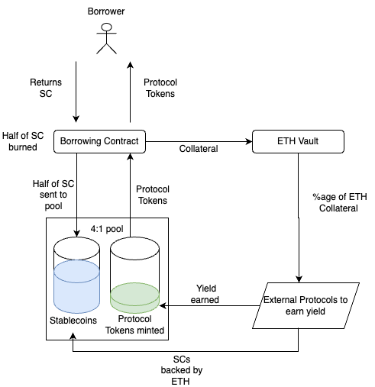

Fig.4. Protocol Tokens as Reserve Currency

Here, we will offer the Loan to Value (LTV) ratio of 80% with the protection offered for 80% of the collateral amount in return for option fees the borrowers are paying. Liquidation will not occur unless the collateral value falls below 80%.

If we take a below scenario

Collateral = ETH price = $1000
- The borrower deposits 1 ETH as collateral and borrows 80% of SC, i.e 800 SC.
- The borrower pays option fees to get downside protection and get a call option.
- Borrower takes 800 SCs and invests in some token.

The token decreases in price by 50 %, so the borrower has lost 400 SCs due to speculation.

The borrower must purchase an additional $400 worth of stablecoins from the market to repay the $800 stablecoin loan.

If the Collateral value also falls to 60 %, then there is no need to return the whole $800 SC instead, the borrower has to return $600 SC only. This is primarily due to the 80% downside protection provided by the mechanism. Since CDS swap depositors receive premiums in the form of option and swap fees, their capital will be utilized to provide downside protection for any decline in value beyond 80% of the collateral amount. In the specific scenario mentioned, the protocol will utilize CDS capital to cover $200 worth of value.
- Conclusion

The issuer issues the Trinity stablecoin to borrowers while enabling full protection of their collateral amount through a combination of Credit Default swaps and taking a Delta-neutral position on the price of Collateral at the time of borrowing. The protocol allows a Loan to Value ratio of 100% for borrowers and a high yield return for users with a Credit Default swap position. The protocol also utilizes derivatives like options to facilitate fee exchange among different users and capture the upside of the collateral amount. The main innovation of this protocol is the utilization of Credit Default swaps and options derivatives which work together to deliver high capital efficiency for borrowers and lenders. Another unique innovation is the diversification of risky positions through transferring risk from short-term holders to longer-term positions and proactive management of positions near liquidation territory. This stablecoin will serve an immediate need of retail and institutional participants with respect to risk and return tradeoff. The protocol also brings to the market new financial products like Credit Default swap and Options, which, instead of being an independent product in itself, are facilitating high capital efficiency and peg of stable coin, thus capturing an established demand and needs of the market.
Conflict of Interest
The authors declare that they have no conflict of interest.

Appendix

We are adding a financial model where we tested our model. We have built the model for ten borrowers and 10 CDS depositors coming at different times at different ETH prices. Our model has the potential to be extrapolated to thousands of borrowers and CDS depositors. We have also incorporated calculations for changes in the P/L of the CDS pool with the fluctuation of the ETH price. Additionally, we have determined the split of P/L among all CDS depositors during each new event, such as opening a new CDS position, a new borrower entering, a borrower closing their position, or any contract calls by external users. This core model of our See-Saw function is where assets move between the ETH Vault and CDS pool with changes in ETH prices.

Table 3 shows the ETH price changes over a couple of days. We observed the change in ETH price over a four-month period from 26/07/2022 to 27/11/2022 and calculated the daily and annual ETH volatility.

Table 4 applies a random number generator function for CDS deposit amounts over 100 days by tracking ETH prices over the same period. We then calculate the LTV ratios and sum them upto the values which breach the LTV ratio beyond a standard industry-wide figure of 60% LTV. We can determine the total amount required from the CDS pool and CDS depositors by using this method. Another method of LP tokens minting mechanism to calculate P/L of every CDS position is shown in table 5.

By examining the total shares/LP tokens owned by the CDS depositor, we can determine the final CDS amount for any open CDS position at any given time, as shown in Table 6. This is made possible by accounting for the change in the CDS pool's total value resulting from the fluctuation in ETH price.

Table 1. Borrowers and 10 CDS depositors at different ETH prices
Day | Total ETH | Initial ETH capital | ETH price | Initial CDS amount | P/L of CDS Pool | CDS depositors | CDS Depositor %age of ETH price
1 | 51 | 50000 | 1000 | 10000 |  | 1000 | 1
2 | 52 | 50000 | 1010 | 10000 | 510 | 1000 | 0.9900990099
3 | 53 | 50000 | 1020 | 10000 | 1030 | 1000 | 0.9803921569
4 | 54 | 50000 | 1030 | 10000 | 1560 | 1000 | 0.9708737864
5 | 55 | 50000 | 1040 | 10000 | 2100 | 1000 | 0.9615384615
6 | 56 | 50000 | 1030 | 10000 | 1550 | 1000 | 0.9708737864
7 | 57 | 50000 | 1020 | 10000 | 990 | 1000 | 0.9803921569
8 | 58 | 50000 | 1010 | 10000 | 420 | 1000 | 0.9900990099
9 | 59 | 50000 | 1000 | 10000 | -160 | 1000 | 1
10 | 60 | 50000 | 950 | 10000 | -3110 | 1000 | 1.052631579
 |  |  |  |  |  |  | 9.896899947

Table 2. Total/Net ETH Vault and Total/Net CDS Pool with Pool ratios
Initial CDS amount | Total CDS pool | Net value of CDS Pool | P/L of ETH Pool | ETH pool at market price | ETH Pool with P/L | Net ETH pool value | Ratio | Inverse of Ratio
10000 | 11000 | 11000 |  | 51000 | 51000 | 51000 | 0.216 | 4.636
10000 | 12000 | 12510 | -510 | 52520 | 52010 | 52010 | 0.238 | 4.198
10000 | 13000 | 14030 | -1030 | 54060 | 53030 | 53030 | 0.260 | 3.853
10000 | 14000 | 15560 | -1560 | 55620 | 54060 | 54060 | 0.280 | 3.575
10000 | 15000 | 17100 | -2100 | 57200 | 55100 | 55100 | 0.299 | 3.345
10000 | 16000 | 17550 | -1550 | 57680 | 56130 | 56130 | 0.304 | 3.287
10000 | 17000 | 17990 | -990 | 58140 | 57150 | 57150 | 0.309 | 3.232
10000 | 18000 | 18420 | -420 | 58580 | 58160 | 58160 | 0.314 | 3.180
10000 | 19000 | 18840 | 160 | 59000 | 59160 | 59160 | 0.319 | 3.132
10000 | 20000 | 16890 | 3110 | 57000 | 60110 | 60110 | 0.296 | 3.375

Table 3. Annual Volatility
Eth Price | Date | Daily returns | Daily volatility | Annual volatility
1215.480165 | 11/27/22 0:00
1216.120944 | 11/26/22 0:00 | 0.001 | 3.35% | 32.02%
1190.840868 | 11/25/22 0:00 | -0.021
1199.777785 | 11/24/22 0:00 | 0.007
1163.074472 | 11/23/22 0:00 | -0.031
1110.720153 | 11/22/22 0:00 | -0.046
1122.223882 | 11/21/22 0:00 | 0.010
1193.216625 | 11/20/22 0:00 | 0.061
1210.534792 | 11/19/22 0:00 | 0.014
1214.575382 | 11/18/22 0:00 | 0.003
1205.69334 | 11/17/22 0:00 | -0.007
1230.465701 | 11/16/22 0:00 | 0.020
1259.073674 | 11/15/22 0:00 | 0.023
1230.783049 | 11/14/22 0:00 | -0.023

Table 4. Calculation of CDS Amount
SI.No. | Collateral deposited | Stablecoin borrowed at 60% LTV | Collateral value after week | LTV ratio after 1 week | Breach of LTV | Difference | Total amount required from CDS pool
1 | 345 | 207 | 318.53 | 0.65 | 15.88 | 138 | 20818
2 | 236 | 141.6 | 231.56 | 0.61 | 2.67 | 94.4
3 | 156 | 93.6 | 158.58 | 0.59 | -1.55 | 62.4
4 | 803 | 481.8 | 812.90 | 0.59 | -5.94 | 321.2
5 | 258 | 154.8 | 267.45 | 0.58 | -5.67 | 103.2
6 | 224 | 134.4 | 248.15 | 0.54 | -14.49 | 89.6
7 | 851 | 510.6 | 954.78 | 0.53 | -62.27 | 340.4
8 | 371 | 222.6 | 382.68 | 0.58 | -7.01 | 148.4
9 | 912 | 547.2 | 935.88 | 0.58 | -14.33 | 364.8
10 | 287 | 172.2 | 298.99 | 0.58 | -7.19 | 114.8
11 | 911 | 546.6 | 958.09 | 0.57 | -28.25 | 364.4
12 | 441 | 264.6 | 441.18 | 0.60 | -0.11 | 176.4
13 | 723 | 433.8 | 705.52 | 0.61 | 10.49 | 289.2
14 | 890 | 534 | 1055.66 | 0.51 | -99.39 | 356

Bonds Tokens

In case the fees offered are less for CDS owners compared to the downside protection offered, we will be generating a new token called bond/hedge token which will be given to CDS once they unlock their deposit after 1 month. This bond/hedge token will have a maturity of 6 months. One bond/ hedge token equals to 100 stable coins at maturity after 6 months. Therefore, after six months the CDS owner can use this bond/hedge token to get the total value (100 stablecoins). Other participants can also trade this bond/hedge token before maturity.

Table 5. LP Tokens Minting Mechanism
Total CDS Deposited by users | CDS Amount Deposited at periodic intervals | Balance of CDS | Shares minted for the CDS deposit | Total shares
10000 | 10000 | 10000 | 10000 | 10000
11000 | 1000 | 11000 | 1000 | 11000
 | 510 | 11510 | 0 | 11000
12000 | 1000 | 12510 | 955.6907037 | 11955.6907
 | 520 | 13030 | 0 | 11955.6907
13000 | 1000 | 14030 | 917.5510901 | 12873.24179
 | 530 | 14560 | 0 | 12873.24179
14000 | 1000 | 15560 | 884.1512221 | 13757.39302
 | 540 | 16100 | 0 | 13757.39302
15000 | 1000 | 17100 | 854.4964606 | 14611.88948
 | -550 | 16550 | 0 | 14611.88948
16000 | 1000 | 17550 | 882.893624 | 15494.7831
 | -560 | 16990 | 0 | 15494.7831
17000 | 1000 | 17990 | 911.9942967 | 16406.7774
 | -570 | 17420 | 0 | 16406.7774
18000 | 1000 | 18420 | 941.8356715 | 17348.61307
17840 | -580 | 17840 | 0 | 17178.73205
18840 | 1000 | 18840 | 962.9334111 | 18141.66546
 | -2950 | 15890 | 0 | 15078.10991
 | 1000 | 16890 | 948.9055954 | 16027.01551

Table 6. Total Shares Left in CDS Pool
Shares minted for the CDS deposit | Total shares | Shares burned | Total Amount during withdrawal | Final CDS Amount withdrawn
10000 | 10000 | 0
1000 | 11000 | 0
0 | 11000 | 0
955.6907037 | 11955.6907 | 0 | 1046.363636 | 1046.363636
0 | 11955.6907 | 0
917.5510901 | 12873.24179 | 0 | 1043.333333 | 1089.857568
0 | 12873.24179 | 0
884.1512221 | 13757.39302 | 0 | 1040.769231 | 1131.028239
0 | 13757.39302 | 0
854.4964606 | 14611.88948 | 0 | 1038.571429 | 1170.279862
0 | 14611.88948 | 0
882.893624 | 15494.7831 | 0 | 963.3333333 | 1132.639282
0 | 15494.7831 | 0
911.9942967 | 16406.7774 | 0 | 965 | 1096.498085
0 | 16406.7774 | 0
941.8356715 | 17348.61307 | 0 | 966.4705882 | 1061.756345
0 | 17178.73205 | -169.8810152 |  | 160
962.9334111 | 18141.66546 | 0 | 967.7777778 | 1038.493408
0 | 15078.10991 | -3063.555554 |  | 2950
948.9055954 | 16027.01551 | 0 | 844.7368421 | 867.3074719

References
- The Free-Banking Era: A Lesson for Today? Economic Insights, Third Quarter 2016, Federal Reserve Bank of Philadelphia Research Department.
- https://country.eiu.com/article.aspx?articleid=1532551136&Country=United+States&topic=Economy&sub_1
- Volatility and the Allegory of the Prisoner’s Dilemma – False Peace, Moral Hazard, and Shadow Convexity, October 2015.
- https://docs.makerdao.com/
- Clements, Ryan, Built to Fail: The Inherent Fragility of Algorithmic Stablecoins (October 28, 2021). 11 Wake Forest L. Rev. Online 131 (October 2021), Available at SSRN: https://ssrn.com/abstract=3952045 or http://dx.doi.org/10.2139/ssrn.3952045
- https://hackernoon.com/tokenomics-of-different-stablecoins-ttg33ut
- Antonio Briola, David Vidal-Tomás, Yuanrong Wang, Tomaso Aste, Anatomy of a Stablecoin’s failure: The Terra-Luna case, Finance Research Letters,
- Saengchote, Kanis, A DeFi Bank Run: Iron Finance, IRON Stablecoin, and the Fall of TITAN (July 16, 2021). Available at SSRN: https://ssrn.com/abstract=3888089 or http://dx.doi.org/10.2139/ssrn.3888089
- https://hbr.org/2021/08/stablecoins-and-the-future-of-money
- https://www.hkma.gov.hk/media/eng/publication-and-research/research/research-memorandums/2022/RM09-2022.pdf
- K. Jarno and H. Kołodziejczyk, “Does the Design of Stablecoins Impact Their Volatility?,” Journal of Risk and Financial Management, vol. 14, no. 2, p. 42, Jan. 2021, doi: 10.3390/jrfm14020042.
- Michael Darlin et.al,”Debt-Financed Collateral and Stability Risks in the DeFi Ecosystem”, arXiv:2204.11107v2 [q-fin.TR] 7 Jun 2022.
- Morten L. Bech, Intraday Liquidity Management: A Tale of Games Banks Play, FRBNY Economic Policy Review / September 2008.
- Hassan, M., Ngow, T., Yu, JS. et al. Determinants of credit default swaps spreads in European and Asian markets. J Deriv Hedge Funds 19, 295–310 (2013). https://doi.org/10.1057/jdhf.2014.1
- https://compound.finance/markets

